KE13N -

Functionality
The Excel template created in Customizing can be copied as often as required and used to create planning data in Excel. By using the uploading function for Excel, you can transfer the individual files into the SAP system. This means that planning data can be entered into different PCs, local planning thereby being possible.

Scenario
Upload Sales Plan file under the name “SALES.TXT”.

Requirements
The file name adheres to the generic file name, so that it can be assigned to the file description correctly.

Menu Path | Accounting → Controlling → Profitability Analysis → Planning → Integrated Planning → Upload from Excel → KE13N - Execute
Transaction Code | KE13N

1. Double click on KE13N – Execute.
Flexible Upload

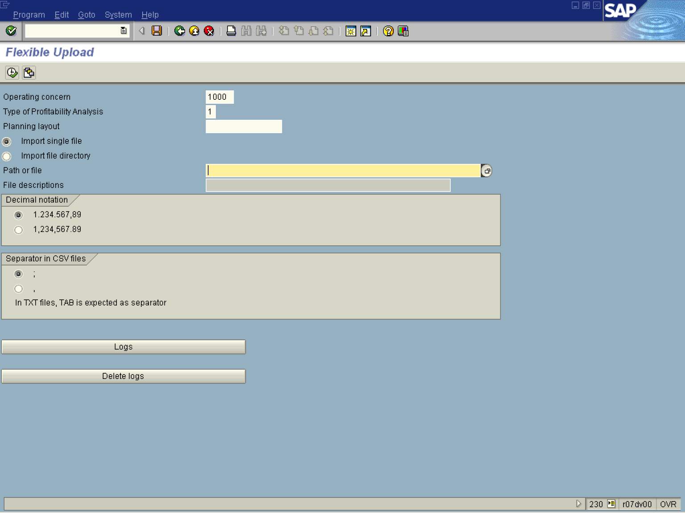

2. Update the following fields:

Field Name | Field Description | Values
Operating concern | A unique four-character key for the CO organizational unit operating concern. | Example: 1000
Type of Profitability Analysis | Costing-based Profitability Analysis and/or account-based Profitability Analysis. | Example: 1

3. Press [F4] or Click the Search button in the Path or file field.

File selection
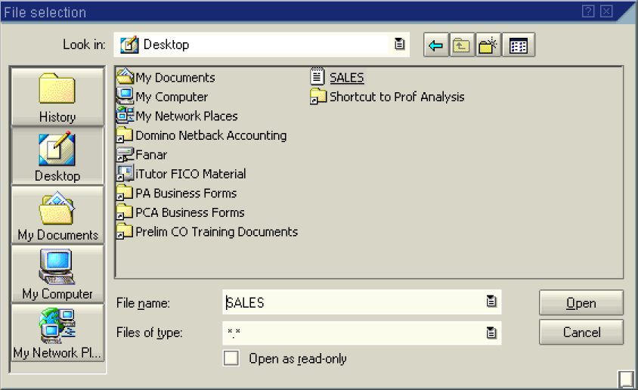

4. Select the SALES file in list box.
5. Click the Open 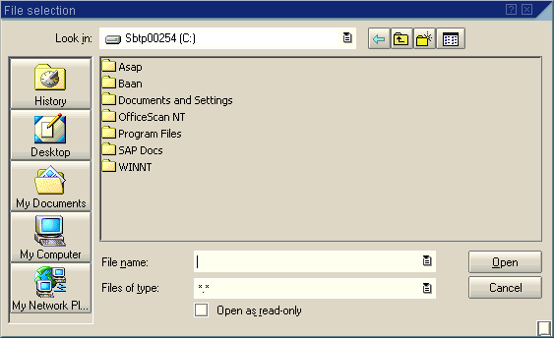 button.

Flexible Upload

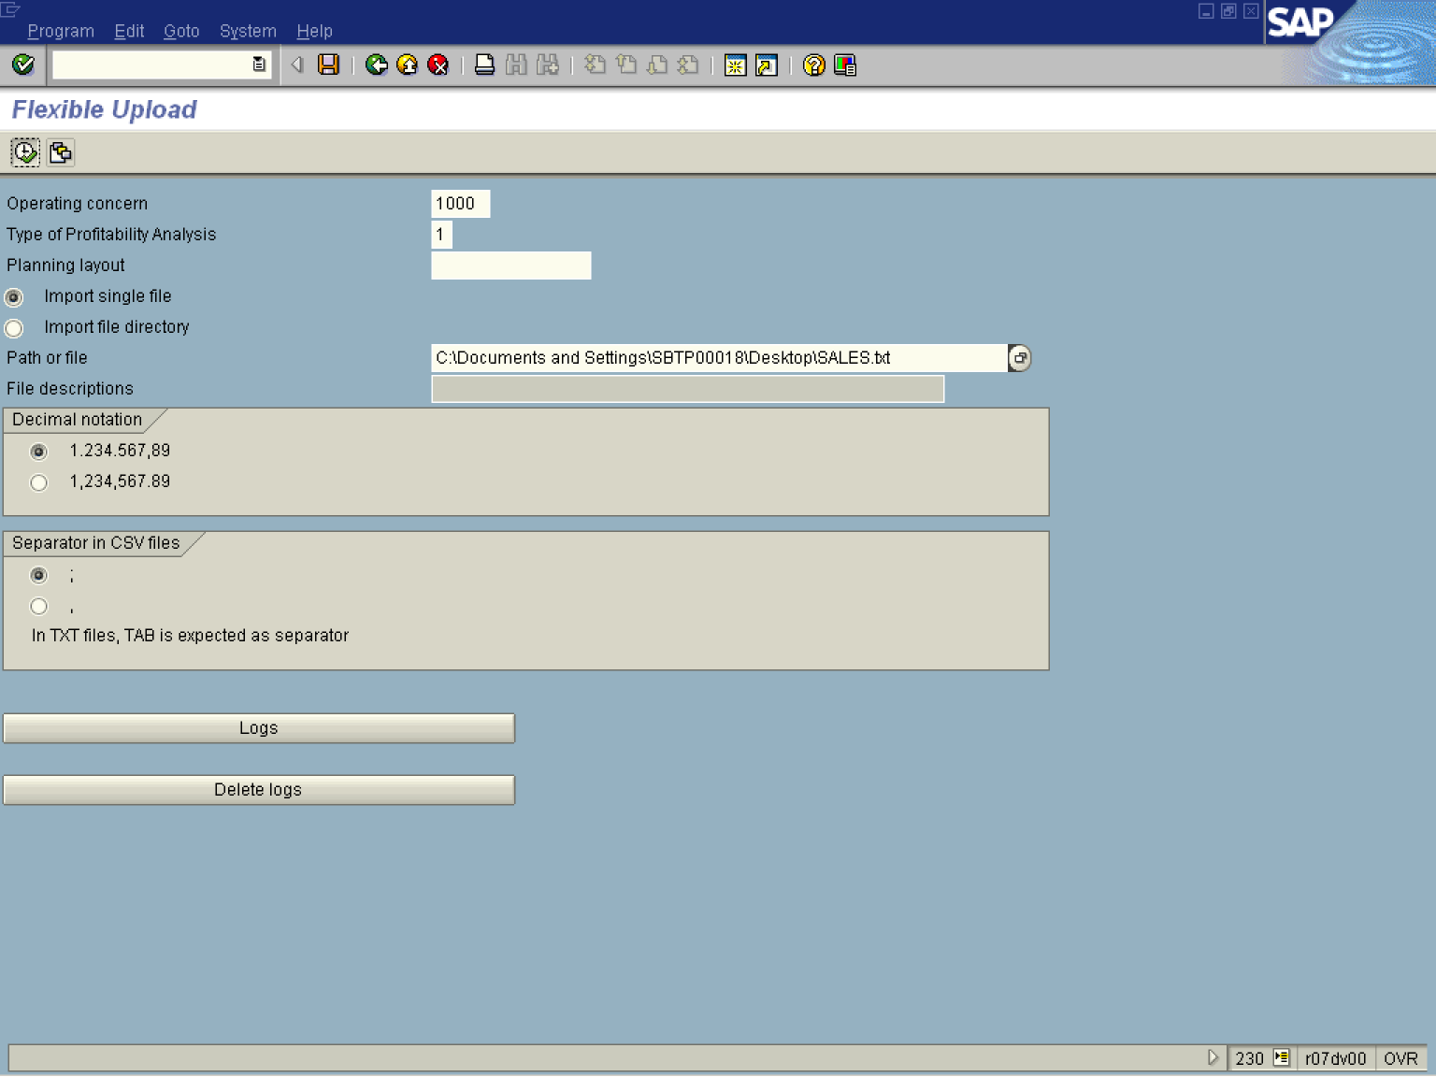

6. Click the Execute button.

Flexible Upload

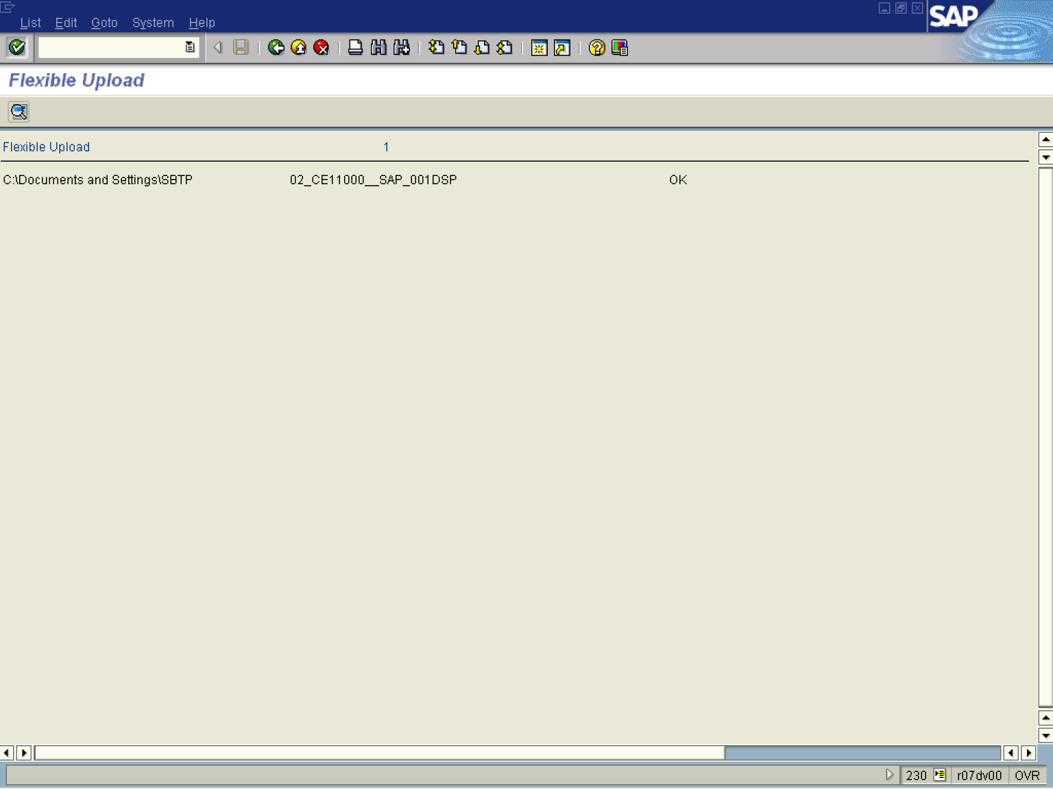

Note: If there are problems in the upload, make sure that the “Totals” line in the text file to be uploaded is deleted (last line).

7. Click the Back button.

Flexible Upload

8. Click the Back button to go back to SAP Easy Access screen.

